**METROPOLITAN LIFE INSURANCE**

**MetLife – Shared Services**

**Form Analysis & Comparison Tool**

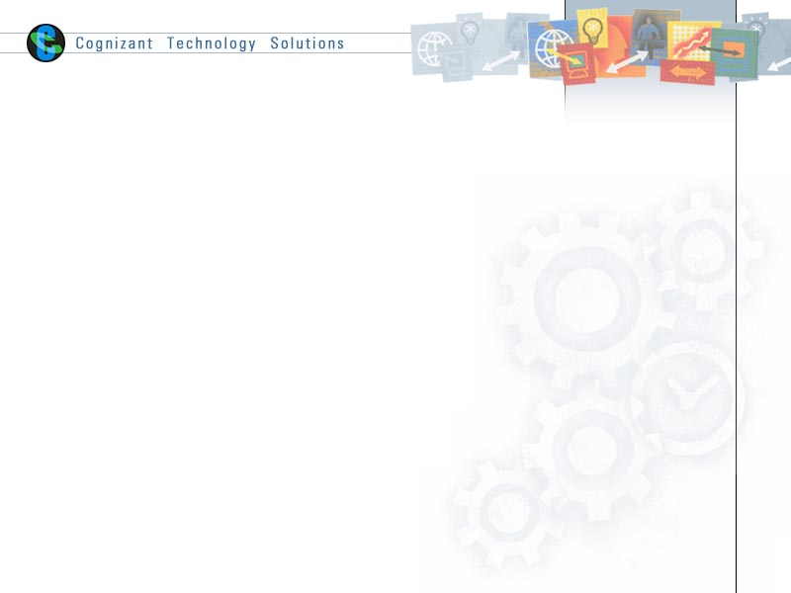

|  |  |  |  |
| --- | --- | --- | --- |
|  | **Prepared By** | **Reviewed by** | **Approved By** |
| **Name** | Saneesh P S | Priya Sundararaj |  |
| **Role** | Team Member | Team Lead |  |
| **Signature** | Saneesh P S | Priya Sundararaj |  |
| **Date** | 28/06/2016 | 29/06/2016 |  |

1. Setup the Workspace

* Copy the “**Forms Analysis & Comparison Tool”** folder from below share path and place it in the local “**D**:” drive.

Source - \\ctsintbmntappa\MetLife_eOPS\eOPS Archive\04. Tools\Forms Analysis & Comparison Tool\

Destination – D:\

* Open folder **D:\Forms Analysis & Comparison Tool\Batch File** and run **CreateWorkingFolders.bat** to create the working directories for the first time use.

1. Form Analysis/Comparison - How to use UI

* Open folder **D:\Forms Analysis & Comparison Tool\** and
* Open the **Forms Analysis & Comparison Tool.html** in Internet Explorer. (Note: use only IE, note supported in Chrome)
* Select the required tab, place the inputs as per the instructions and click the button Generate Report.

**Use the batch method if you don’t want to use UI screen or if not supported**

1. Form Analysis Tool – How to use Batch

* To generate Section level report

1. Place required “FOR” files in input path - D:/Forms Analysis Tool/input/formanalysis/

2. Run **GenerateSectionLevelReport.bat**

3. The Report will be generated in path - D:/Forms Analysis Tool/output/formanalysis/

* To generate Field level report

1. Place required “FAP XMLs” in input path - D:/Forms Analysis Tool/input/formanalysis/

2. Run **GenerateFieldLevelReport.bat**

3. The Report will be generated in path - D:/Forms Analysis Tool/output/formanalysis/

* To generate Group level report

1. Place required “GRP” files in input path - D:/Forms Analysis Tool/input/formanalysis/

2. Run **GenerateGroupLevelReport.bat**

3. The Report will be generated in path - D:/Forms Analysis Tool/output/formanalysis/

* To generate XDD report

1. Place required “XDD” files in input path - D:/Forms Analysis Tool/input/formanalysis/

2. Run **GenerateXDDReport.bat**

3. The Report will be generated in path - D:/Forms Analysis Tool/output/formanalysis/

1. Form Comparison Tool – How to use Batch

* To Compare QA and PROD components and generate comparison report

1. Filter all the production components(BDF, FOR, FAP, DAL, XDD and LOG) with last version and last revision and extract it to folder :

**D:/Forms Analysis Tool/input/formcomparison/Prod-Components/**

1. Right click the filtered results and select "Export this Window to file" and save that file with the name of "**prod_components.csv**" in input path –

**D:/Forms Analysis Tool/input/formcomparison/**

1. Filter all latest prod ready components (BDF, FOR, FAP, DAL, XDD and LOG) and extract it to folder :

**D:/Forms Analysis Tool/input/formcomparison/QA-Components/**

1. Right click the filtered results and select "Export this Window to file" and save that file with the name of "**qa_components.csv**" in input path –

**D:/Forms Analysis Tool/input/formcomparison/**

1. Run **GenerateComponentsComparisonReport.bat**
2. The Report will be generated in output path –

**D:/Forms Analysis Tool/output/ formcomparison /**

1. The Report will be generated in path –

**D:/Forms Analysis Tool/output/ formcomparison /**

Screenshots:

